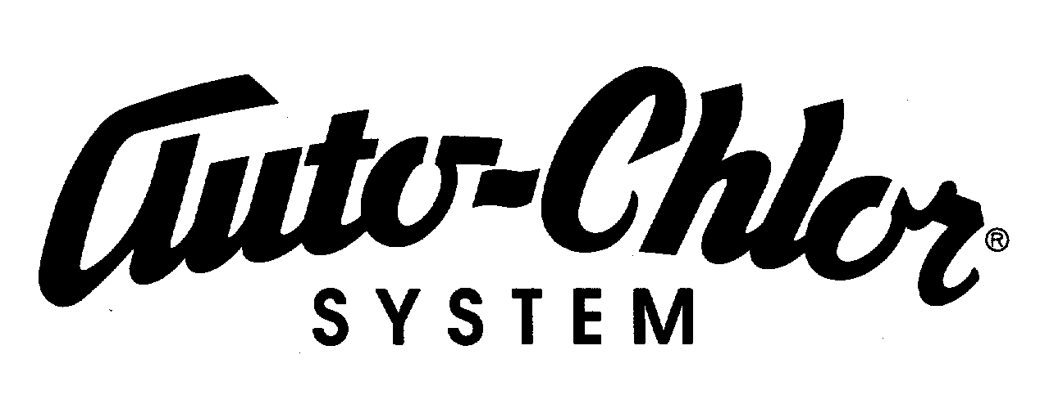

3055 Commerce Way, Hapeville, GA 30354 Phone: 404/766-0827 Fax: 404/766-7131

April 11, 2013

Clerk of the Bankruptcy Court
United States Bankruptcy Court
Northern District of Georgia
75 Spring Street SW
Atlanta, GA 30303

RE: Ch 11, Case No. 13-51482-pwb
Buckhead Pizza Company

Please be advised that the dishwashing machines at the above location belongs to Auto-Chlor System and are not to be considered an asset of the Debtor. Enclosed are copies of our agreements for the equipment.

We have included an original and two copies of this letter and attachments. Please acknowledge your receipt of our notice by return mail in the envelope enclosed.

If you have any questions, please feel free to contact us at the above address or phone.

Thank you for your attention to this matter.

Sincerely,

Kristy Lowery
AUTO-CHLOR SYSTEM

Enclosures
Self Addressed Stamped Envelope

